Here, we will take the program in the folder “Example” as an example.

**Notations:**

**The Matlab's version is R2016b;**

**The yalmip's version is 20210331;**

**The solver is SDPT3-4.0;**

ExampleOfSolvingLMIs.m: An example of solving linear matrix inequalities (44)-(46) in Theorem 2.

**Step.** Please open the file “ExampleOfSolvingLMIs.m”. Click “Run” for the file “ExampleOfSolvingLMIs.m”;

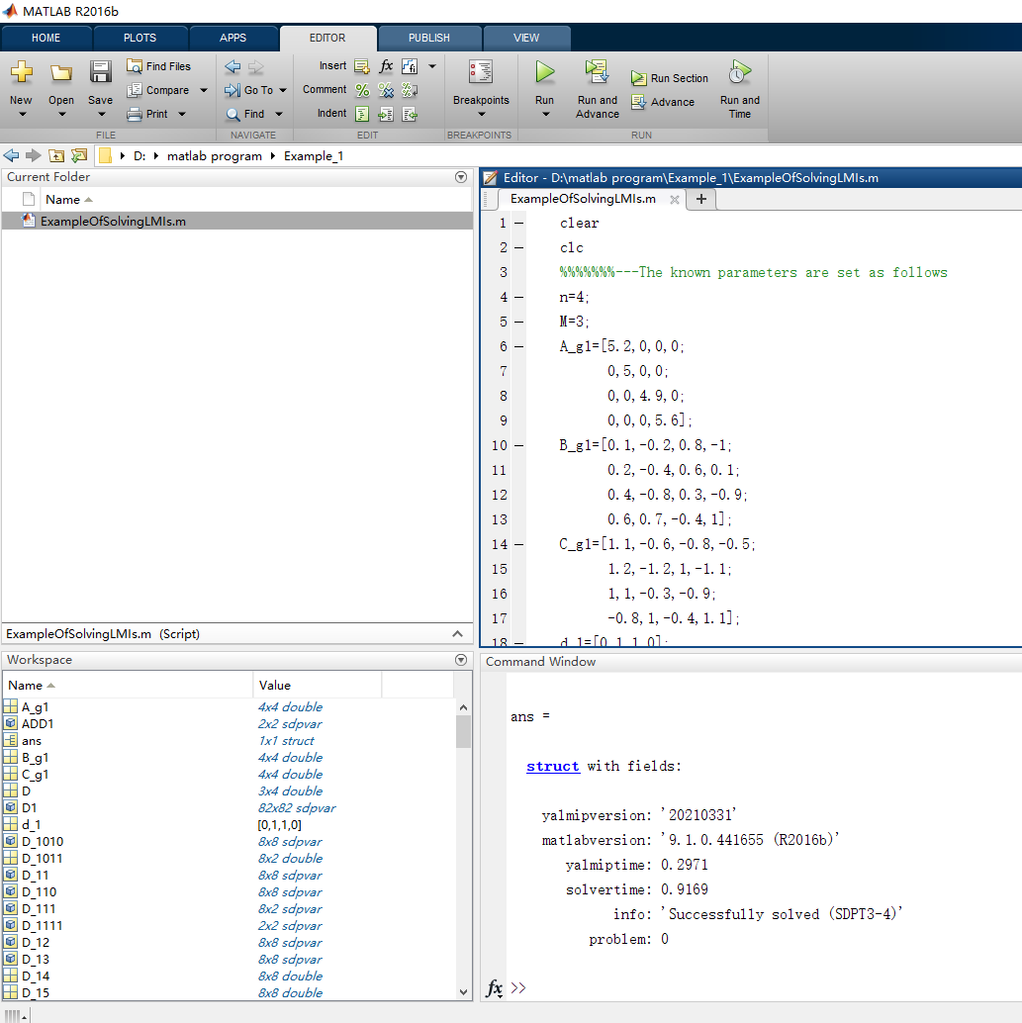

After running, the following text appears in the command window, which means that a feasible solution of the example can be found.

ans =

struct with fields:

yalmipversion: '20210331'

matlabversion: '9.1.0.441655 (R2016b)'

yalmiptime: 0.2971

solvertime: 0.9169

info: 'Successfully solved (SDPT3-4)'

problem: 0